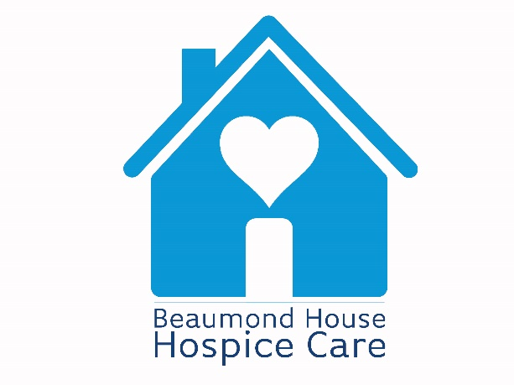

FREE WILL WRITING CAMPAIGN TERMS & CONDITIONS

Supporter Terms and Conditions

- Beaumond House Hospice Care has partnered with local solicitors to offer supporters the opportunity to write their Will for free using the service. Supporters will be asked to complete a form on the Beaumond House website detailing their preferred solicitor. Requests from individuals will be recorded by Beaumond House and referred to each solicitor.
- Beaumond House does not provide the Will writing service. Each partner solicitor will provide the Will writing service and the responsibility of this service is the solicitors. Each solicitor is independent of Beaumond House.
- It is worth noting that:
  - You must be aged 18 or over to use the service.
  - There is no obligation on users of this free Will service to leave a gift to Beaumond House.
  - Beaumond House recommends that you carry out your own independent research on the providers who are part of the campaign, and only choose the services of the solicitors if you are satisfied with their quality of service.
- Beaumond House, and its partner solicitors, reserve the right to withdraw this free Will offer at any time.
- Beaumond House is working in partnership with local solicitors for supporters to write a simple Will with no charge to the charity.
- This offer covers the cost of a simple individual Will. If you need a more complex Will the solicitor will advise you of this. Any cost incurred is not covered by Beaumond House and will be charged to you. Your preferred solicitor will make it clear if this service is or isn’t suitable to your needs. Beaumond House do not pay any additional costs above what is covered by the free Will offer.
- Our registered address is Beaumond House Hospice Care, 32 London Road, Newark, NG24 1TW.
- Beaumond House is a registered Charity No. 1025442 (England and Wales).

